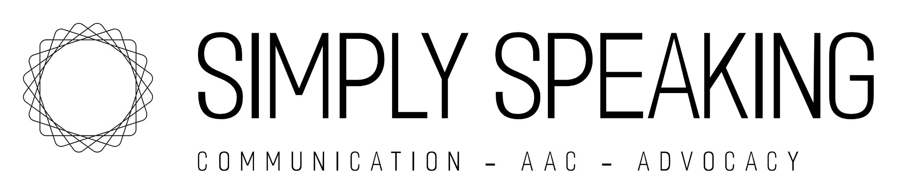
Terms and Conditions
Welcome to Simply Speaking. By using our services, including SMS/text reminders, you agree to the following terms and conditions:

1. SMS Campaign Details
- Campaign Name: Simply Speaking “Appointment Reminders”
- Description: You will receive SMS/text messages related to your appointments, scheduling updates, and important practice information.
- Message Frequency: Message frequency may vary, but typically includes reminders before scheduled appointments and occasional updates.
- Message & Data Rates: Message and data rates may apply depending on your mobile carrier.

2. Customer Care Information
If you have questions, need help, or wish to change your communication preferences, contact us at:
- Phone: 408-579-9512
- Email: simplyspeakingsv@gmail.com

3. Opt-Out Information
You may opt out of receiving SMS/text messages at any time by replying STOP to any message you receive.
To re-subscribe, reply START.

4. Privacy
We respect your privacy. Please see www.simplyspeakingsv.com for details.
- We will not sell, rent, or share your mobile information with third parties for promotional or marketing purposes.

5. Services
Simply Speaking provides private speech therapy, AAC support, and IEP advocacy services. Services are private pay only. Superbills may be provided for insurance reimbursement, but reimbursement is not guaranteed.

6. Limitation of Liability
We are not liable for delays or failures in message delivery, as delivery depends on your carrier and network coverage.

7. Changes to Terms
We may update these Terms and Conditions as needed. The most current version will always be available on our website.

